Coursework Submission Cover Sheet
Student ID (LMU ID) | 25040355
Module Code and Name | CS7050NM ARTIFICIAL INTELLIGENCE
Assessment No/Title | Assessment 1 – Coursework
Assessment Submission Deadline | 2026-10-09
Module Leader | Mr.Ishan Wijethunga


.
CS7050NM Artificial Intelligence
Problem Solving Using State-Space Search and Knowledge-Based Inference
Group Report and Individual Report

Table of Contents
Part A - Group Report
1. Introduction
2. State-Space Definition
3. Maze Representation in Python
4. Success Criteria
5. Breadth-First Search (BFS)
6. Cost Calculation
7. State-Space Visualization
8. Logical Theory Using First-Order Logic
9. Ground Facts
10. Universally Quantified Rules and Heuristics
11. Group Conclusion
Part B - Individual Report
1. Introduction
2. Dijkstra's Algorithm
3. Python Data Structures
4. Dijkstra Search Process
5. Dijkstra Success Criteria
6. Dijkstra Result and Visualization
7. Knowledge-Based Problem Solving
8. Forward Chaining and GMP
9. Knowledge Base
10. Inference Rules and Goal Statement
11. Execution Trace
12. Program Structure
13. Comparison and Conclusion
References

PART A - GROUP REPORT

1. Introduction
This report talks a solution to the given maze problem using state-space search and First-Order Logic (FOL) mechanisms. The maze contains five rows and six columns. The agent exploring starts at node (0,0) and target to reach the goal node (4,5) without crossing obstacle nodes. For the group task, Breadth-First Search is selected as the blind or an uninformed search algorithm as every valid movement has the same cost. The report also develops a logical theory to represent the same maze using ground facts and universally quantified rules.
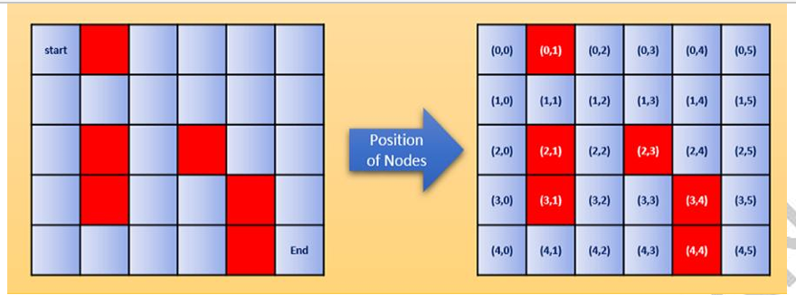
Figure 1 - Maze problem and coordinate representation

2. State-Space Definition
A maze is a very common state-space search problem. A state represents the current position of the agent. In this problem, each valid grid coordinate is treated as a state.
- State: a valid maze coordinate represented as (row, column).
- start/Initial state: (0,0).
- Goal state: (4,5).
- Agent Actions: move Up, Down, Left or Right.
- Note: obstacle cells and positions outside the grid cannot be entered.
- Step cost: each valid movement cost assume that 01.

3. Maze Representation in Python
The maze is represented using simple Python data structures program. Tuples represent node coordinates, a set stores obstacle nodes, and a deque is used as the BFS frontier. Sets are suitable for obstacles and visited nodes because membership checks are efficient.
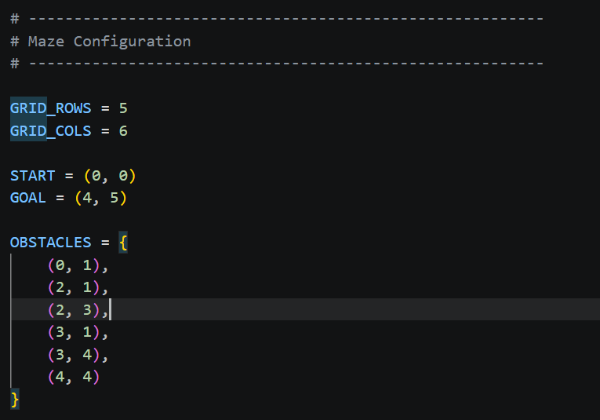
Figure 2 – Maze definition in Python Program

4. Success Criteria
The search succeeds when the node removed from the queue is the goal node. In program terms, the success test is:
if (curr_r, curr_c) == goal:
return path
The solution must start at (0,0), end at (4,5), remain inside the maze, jump only to adjacent nodes, and should never be entered to any obstacle node.
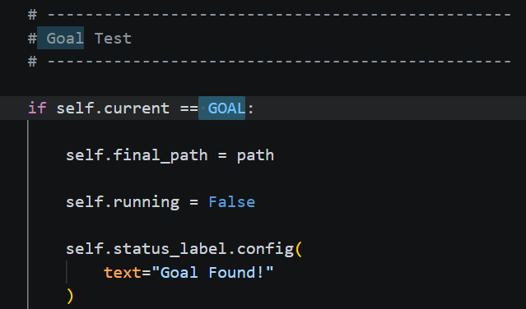
Figure 3 – Success criteria definition in python program

5. Breadth-First Search (BFS)
BFS is an example for uninformed search algorithm. BFS explores nodes step by step and follow a FIFO (First In, First Out) method for searching. Since all movements in the maze have equal cost, BFS is appropriate for finding a shortest path. But it may not be the optimal algorithm.

5.1 BFS Program Logic
- Place the start node in the queue together with the path containing only the start node(0,0).
- Define the start node as visited.
- Remove the oldest node from the queue using popleft().
- Test whether the current node is the goal.
- Generate valid successor nodes in the four allowed directions.
- Add each successor which should be visited to the queue and record the extended path.
- Repeat until the goal(4,5) is reached or if there no path the queue will be empty.

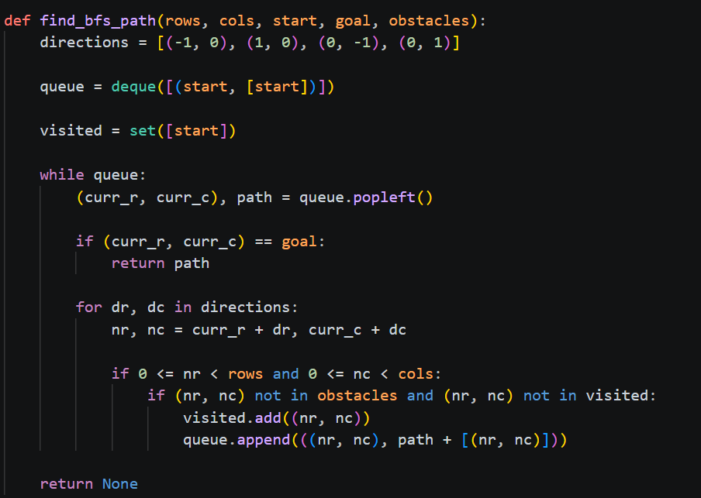
Figure 4 - Basic program for BFS(without visualization)

Visual Representation of BFS
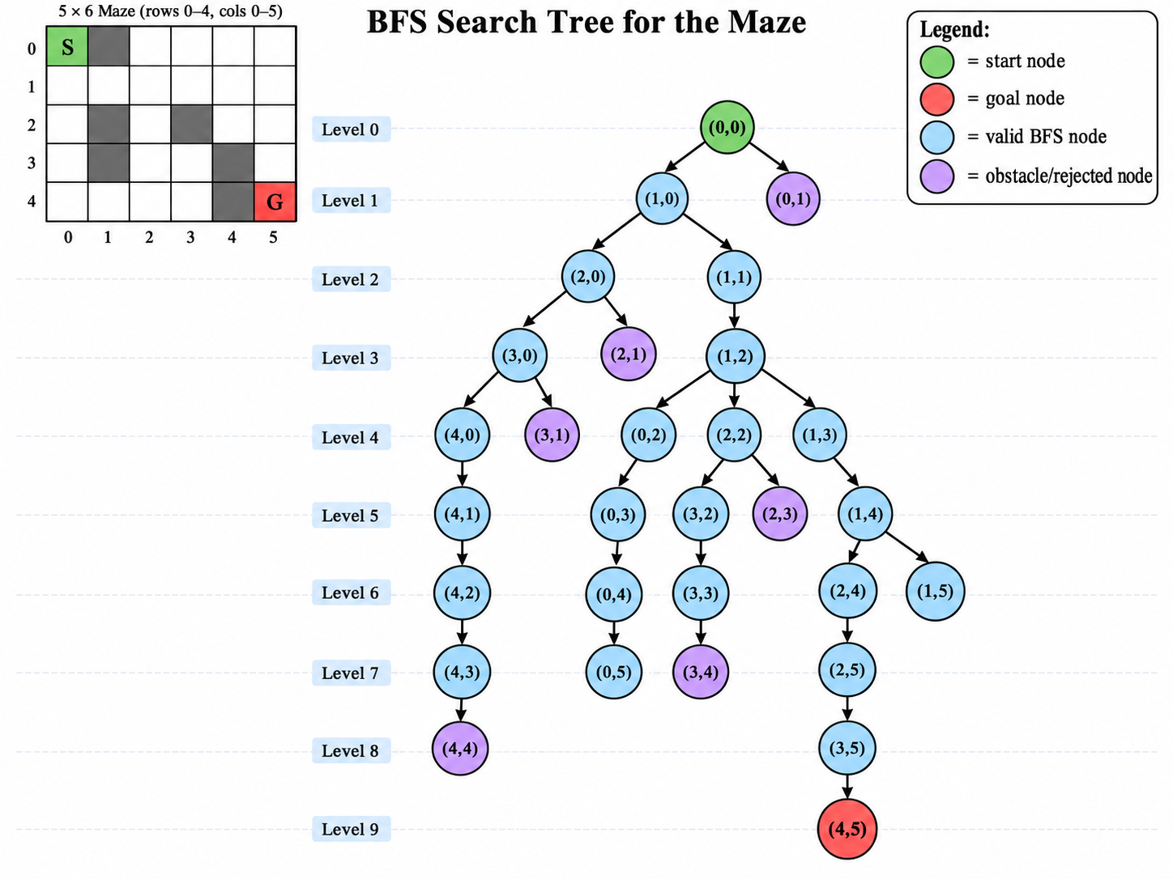
Figure 5 – Visual Representation of BFS Search Tree

Here is a simple, step-by-step explanation of BFS node exploration for the maze represent above.
Step 1 – Start at (0,0).
This is the start node.
Add (0,0) to the queue.
Mark (0,0) as visited.
Step 2 – Explore (0,0).
Check all possible directions: Up, Down, Left, Right.
(0,1) is an obstacle.
(1,0) is free.
Add (1,0) to the queue.
Step 3 – Explore (1,0).
Check nearby nodes.
(0,0) is already visited.
(2,0) is free.
(1,1) is free.
Add (2,0) and (1,1) to the queue.
Step 4 – Explore (2,0).
(1,0) is already visited.
(3,0) is free.
(2,1) is an obstacle.
Add (3,0) to the queue.
Step 5 – Explore (1,1).
(0,1) is an obstacle.
(2,1) is an obstacle.
(1,0) is already visited.
(1,2) is free.
Add (1,2) to the queue.
Step 6 – Explore (3,0).
(2,0) is already visited.
(4,0) is free.
(3,1) is an obstacle.
Add (4,0) to the queue.
Step 7 – Explore (1,2).
(0,2) is free.
(2,2) is free.
(1,1) is already visited.
(1,3) is free.
Add (0,2), (2,2), and (1,3) to the queue.
Step 8 – Explore (4,0).
(3,0) is already visited.
(4,1) is free.
Add (4,1) to the queue.
Step 9 – Explore (0,2).
(0,1) is an obstacle.
(0,3) is free.
(1,2) is already visited.
Add (0,3) to the queue.
Step 10 – Explore (2,2).
(1,2) is already visited.
(3,2) is free.
(2,1) is an obstacle.
(2,3) is an obstacle.
Add (3,2) to the queue.
Step 11 – Explore (1,3).
(0,3) may already be discovered.
(2,3) is an obstacle.
(1,2) is already visited.
(1,4) is free.
Add (1,4) to the queue.
Step 12 – Explore (4,1).
(3,1) is an obstacle.
(4,0) is already visited.
(4,2) is free.
Add (4,2) to the queue.
Step 13 – Explore (0,3).
(0,2) is already visited.
(0,4) is free.
(1,3) is already visited.
Add (0,4) to the queue.
Step 14 – Explore (3,2).
(2,2) is already visited.
(4,2) may already be discovered.
(3,1) is an obstacle.
(3,3) is free.
Add (3,3) to the queue.
Step 15 – Explore (1,4).
(0,4) may already be discovered.
(2,4) is free.
(1,3) is already visited.
(1,5) is free.
Add (2,4) and (1,5) to the queue.
Step 16 – Reach the goal.
BFS eventually explores (4,5).
(4,5) is the target goal.
The search stops.

6. Cost of traverse
Each movement from one valid node to an adjacent node costs 1. Therefore, the path cost is assume that equal to the number of movements, which is (n-1) if total number of nodes are n.
Path Cost = len(path) - 1
One shortest path is:
(0,0) -> (1,0) -> (1,1) -> (1,2) -> (1,3) -> (1,4) -> (1,5) -> (2,5) -> (3,5) -> (4,5)
Total Cost = 9

7. State-Space Visualization
The search process can be displayed using a graphical interface. The visualization allows the user to observe the current node, visited nodes, frontier/queue, obstacles, and the final path. This is useful for explaining how BFS expands the state space.
Colour | Meaning | Purpose
Green | Start | Starting state (0,0)
Red | Goal | Goal state (4,5)
Black | Obstacle | Impassable node
Light Blue | Visited | Node already explored
Purple | Final Path | Shortest path returned by BFS

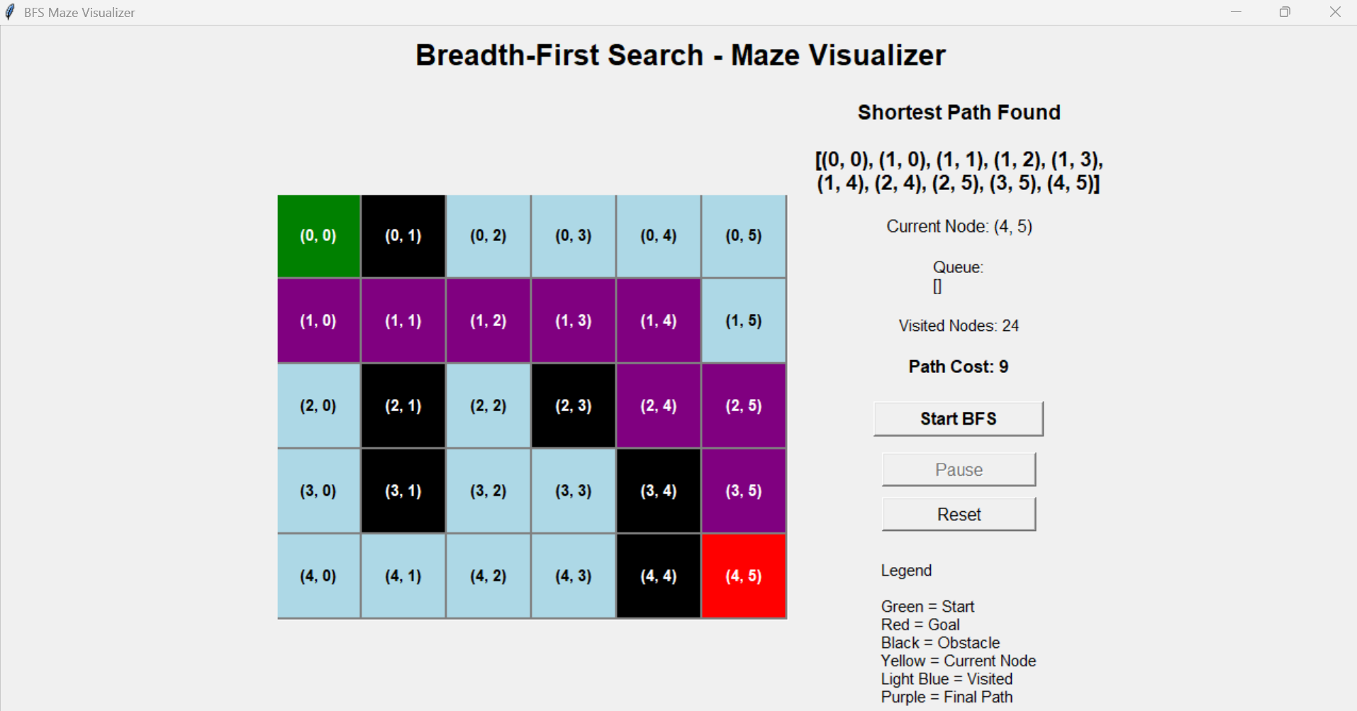
Figure 6 – Path to reach the goal

8. Logical Theory Using First-Order Logic
The maze can be expressed in the form of a knowledge base by means of First-Order Logic, with the ground facts giving specific details about the maze and the universally quantified rules outlining the general principles of movement and reasoning..

9. Ground Facts
Ground formulas include only constants and have no variables. The following ground facts represent the starting position, the goal, the obstacles and the free cells.
Start(0,0)
Goal(4,5)
Obstacle facts:
Obstacle(0,1)
Obstacle(2,1)
Obstacle(2,3)
Obstacle(3,1)
Obstacle(3,4)
Obstacle(4,4)
Examples of free-cell facts:
Free(0,0)
Free(0,2)
Free(0,3)
Free(0,4)
Free(0,5)
Free(1,0)
Free(1,1)
Free(1,2)
...
Free(4,5)
All non-obstacle nodes are represented as Free facts.

10. Universally Quantified Rules and Heuristics

10.1 Adjacency Rules
∀x∀y Adj(x,y,x,y+1) [Right]
∀x∀y Adj(x,y,x,y-1) [Left]
∀x∀y Adj(x,y,x+1,y) [Down]
∀x∀y Adj(x,y,x-1,y) [Up]

10.2 Valid Movement Rule
∀x∀y∀x1∀y1 ((Adj(x,y,x1,y1) ∧ Free(x1,y1)) → CanMove(x,y,x1,y1))
This rule states that the agent can move to a node if it is adjacent to the current node and is free.

10.3 Obstacle Rule
∀x∀y (Obstacle(x,y) → ¬Free(x,y))

10.4 Goal Rule
∀x∀y ((At(x,y) ∧ Goal(x,y)) → OutOfMaze)

10.5 Heuristic Rules
Useful preferences for intelligent movement are given by the following FOL heuristics. They are knowledge rules and not part of the blind BFS control strategy.
∀x∀y∀x1∀y1 ((CanMove(x,y,x1,y1) ∧ Closer(x1,y1,4,5)) → Prefer(x1,y1))
∀x∀y (Obstacle(x,y) → Avoid(x,y))
∀x∀y (Visited(x,y) → ¬MoveTo(x,y))

11. Group Conclusion
The Group task mainly focusses on completing Maze representation using BFS and First order logic. BFS is uninformed and blind algorithm which takes cost as 1 as each movement. Once the problem is solved, the python program was built and It helps to represent BFS and to increase the visual quality visual component was built and it shows clearly how it travers through maze find the goal.
In the next part First Order Logic was built, and it is a knowledge base mechanism.

PART B - INDIVIDUAL REPORT

References
